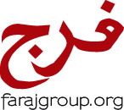
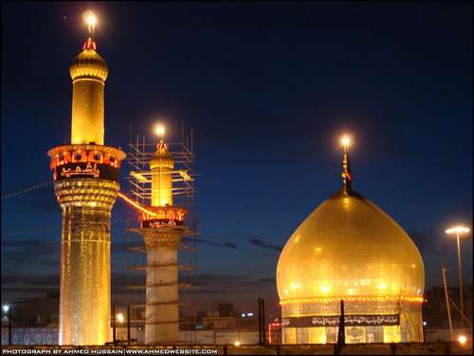
FARAJ GROUP
ARAFAT IN KERBALA
AND EID-E-GHADEER IN NAJAF
AUG 28 - SEP 13, 2017
Date | Destination | Extra Notes
Aug 28 - Mon | Toronto to Dubai | By Emirates Airlines
Aug 29 - Tues | Arrival in Dubai at night | Transit in Dubai
Aug 30 - Wed | Dubai to Baghdad to Kadhmain | Shahadat of Imam Muhammad Baqir A.S.
Aug 31 - Thurs | Kadhmain to Kerbala | SHABBE JUMA MAKHSUSI
Sept 1 - Fri | Kerbala | ARAFAT DAY
Sep 2 - Sat | Kerbala | EID AL HAJJ DAY
Sep 3 - Sun | Kerbala to Sammarrah | Day trip to Sammarrah
Sep 4 - Mon | Kerbala
Sep 5 - Tues | Kerbala to Najaf | Amaals of Masjide Sahlah
Sep 6 - Wed | Najaf
Sep 7 - Thurs | Najaf | Wiladat of Imam Ali Naqi A.S.
Sep 8 - Fri | Najaf | Amaals of Masjide Kufa
Sep 9 - Sat | Najaf | Visit to Ayatullah Sistani
Sep 10 -Sun | Najaf | EID E GHADEER
Sep 11 - Mon | Najaf
Sep 12 - Tues | Najaf to Baghdad airport to Dubai | Sleep the nite in Dubai in transit
Sep 13 - Wed | Dubai to Toronto | Arrival into Toronto in the afternoon

LAND PACKAGE IS U.S $1,500.00 - PLUS AIR FARES WITH GALA TRAVELS

To register or for more information, please contact Shams Dharsi at 905-597-0786, 416-500-7865 or email at shamsd@yahoo.com

Deposit of USD $500 will be required upon registration, along with one passport photocopy and 2 passport size pictures with white background

DEADLINE TO SIGN UP: JULY 1, 2017

