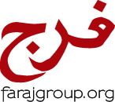
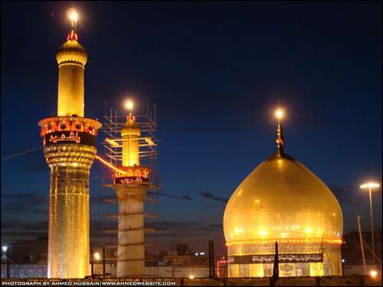
FARAJ GROUP
ARBAEEN IN KERBALA
OCT 30 TO NOV 15, 2017

Date | Destination | Extra Notes
Oct 30 - Mon | Toronto to Dubai | By Emirates Airlines
Oct 31 - Tues | Arrival in Dubai at Night | Transit in Dubai
Nov 1 - Wed | Dubai to Badhdad straight to Najaf
Nov 2 - Thurs | Najaf | Amaals of Masjide Kufa
Nov 3 - Fri | Najaf | Amaals of Masjide Sahlah
Nov 4 - Sat | Najaf | Visit to Ayatullah Sistani
Nov 5 - Sun | Najaf to Kerbala - Non walkers by Bus | Walkers will start today from Najaf to Kerbala
Nov 6 - Mon | Kerbala
Nov 7 - Tues | Kerbala
Nov 8 - Wed | Kerbala | NITE OF ARBAEEN
Nov 9 - Thurs | Kerbala | DAY OF ARBAEEN / SHABBE JUMMA
Nov 10 - Fri | Kerbala
Nov 11 - Sat | Kerbala to Sammarrah | Day trip to Sammarrah
Nov 12 - Sun | Kerbala
Nov 13 - Mon | Kerbala to Kadhmain
Nov 14 - Tues | Kadhmain to Baghdad airport to Dubai
Nov 15 - Wed | Dubai to Toronto | Arrival into Toronto in the afternoon

LAND PACKAGE IS U.S. $1,600.00 - PLUS AIR FARES WITH GALA

To register or for more information, please contact Shams Dharsi at 905-597-0786, 416-500-7865 or email at shamsd@yahoo.com

Deposit of USD $500 will be required upon registration, along with one passport photocopy and 2 passport size pictures with white background

DEADLINE TO SIGN UP: SEPTEMBER 15, 2017

