
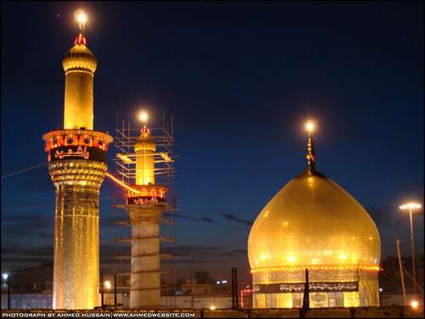
FARAJ GROUP
ASHURA IN KERBALA
SEPT 22 - OCT 6, 2017

Date | Destination | Extra Notes
Sep 22 - Fri | Toronto to Dubai | By Emirates Airlines
Sep 23 - Sat | Arrival in Dubai at nite | Transit in Dubai
Sep 24 - Sun | Dubai to Baghdad straight to Najaf
Sep 25 - Mon | Najaf | Amaals of Masjide Kufa
Sep 26 - Tues | Najaf | Amaals of Masjide Sahlah
Sep 27 - Wed | Najaf | Visit to Ayatullah Sistani
Sep 28 - Thurs | Najaf to Kerbala | SHABBE JUMMA MAKHSUSI
Sep 29 - Fri | Kerbala
Sep 30 - Sat | Kerbala | NIGHT OF ASHURA
Oct 1 - Sun | Kerbala | DAY OF ASHURA
Oct 2 - Mon | Kerbala
Oct 3 - Tues | Kerbala to Kadhmain
Oct 4 - Wed | Kadhmain to Sammarrah | Day trip to Sammarrah
Oct 5 - Thurs | Kadhmain to Baghdad airport to Dubai | Transit in Dubai
Oct 6 - Fri | Dubai to Toronto | Arrival into Toronto in the afternoon

LAND PACKAGE IS U.S $975.00 - PLUS AIRFARES WITH GALA TRAVELS

To register or for more information, please contact Shams Dharsi at 905-597-0786, 416-500-7865 or email at shamsd@yahoo.com

Deposit of USD $500 will be required upon registration, along with one passport photocopy and 2 passport size pictures with white background (small - stamp size)

DEADLINE TO SIGN UP: AUGUST 1, 2017

