
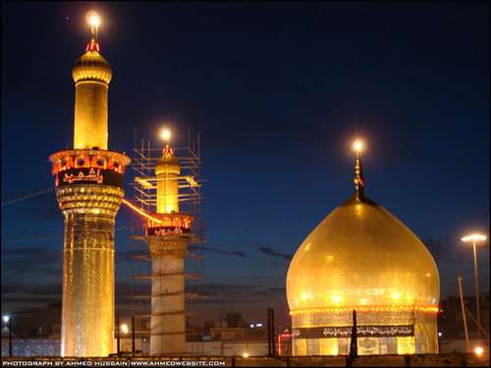
FARAJ GROUP
XMAS HOLIDAYS
DEC 22 TO JAN 3, 2018

Date | Destination | Extra Notes
Dec 22 - Fri | Toronto to Dubai | By Emirates Airlines
Dec 23 - Sat | Arrival in Dubai at Night | Transit in Dubai
Dec 24 - Sun | Dubai to Baghdad straight to Najaf
Dec 25 - Mon | Najaf
Dec 26 - Tues | Najaf
Dec 27 - Wed | Najaf
Dec 28 - Thurs | Najaf to Kerbala | SHABBE JUMMA MAKHSUSI
Dec 29 - Fri | Kerbala
Dec 30 - Sat | Kerbala
Dec 31 - Sun | Kerbala
Jan 1 - Mon | Kerbala to Sammarrah to Kadhmain | Day trip to Sammarrah
Jan 2 - Tues | Kadhmain to Baghdad Airport to Dubai | Transit in Dubai
Jan 3 - Wed | Dubai to Toronto | Arrival into Toronto in the afternoon

LAND PACKAGE IS U.S $1,000.00 - PLUS AIR FARES WITH GALA TRAVELS

To register or for more information, please contact Shams Dharsi at 905-597-0786, 416-500-7865 or email at shamsd@yahoo.com

Deposit of USD $500 will be required upon registration, along with one passport photocopy and 2 passport size pictures with white background

DEADLINE TO SIGN UP: OCT 5, 2017

